[Topic: Preproduction Materials: Virtual, Augmented reality Medical education and practices in medical surgery]
[Amandeep Kaur]
[Preproduction materials]
9th October 2021

Table of Contents
Planning of AR, VR in Medical Surgery 3
Methods 3
Technical Experiment 4
Working Principles of extended reality 5
Visual Design 6
Interactive Design of VR AR 8
VIDEO Presentation 11
References 12

Preproduction Materials: Virtual, Augmented reality Medical education and practices in medical surgery

Planning of AR, VR in Medical Surgery
(Giselle Coelho MD, 2020) The planning of augmented reality with assistance of virtual reality should be deployed on various technological devices. The method of AR map is created in mobile devices, the hybrid model of VR and AR based to construct the diagnosis 3D images, the 3D scan CT scan image the way to identify the method of disease and object to reconsider the point, data has been collected from medical science journals, web of science, science direct, Psycho Info data science.
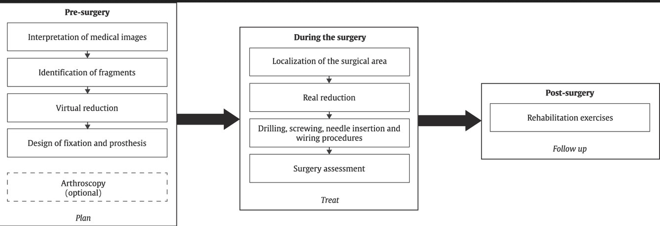
Figure 1: methods of using AR VR during the surgery

Methods
The methods contain of medical research of augmented reality and virtual reality about to look on deeper. Data has been collected of medical science of journals, Google Scholars, Pub medical, SCOPUS Science and journal of medicine studies. The analysis method to capture the various use cases of medical field unit such as various surgery operation method.
- SPINE Surgery
- Orthopedic surgery
- Laparoscopic surgical training
- Neurosurgery
The method of augmented reality based medicine discovery which effectively treat the patient health and aid the patient required medicine on timely manner

Technical Experiment

(Venkatesan, et al., 2021) Virtual reality used for 3D visualization of object in deeper look to identify the disease and identify the object to operate on surgery. Mixed reality and digital extended reality technologies have been accepted on different devices structures. The 3D visualization with 2D display in context of surgery in training session as education institute contain the various informative methods. With the experience of extended reality the extended reality platform works on biomedical education, education training, surgical guidance and molecular data visualization, the enhance training session of medical students which based on augmented reality devices and platform of operation that would be tested in terms of successfully deployment of their educational career.
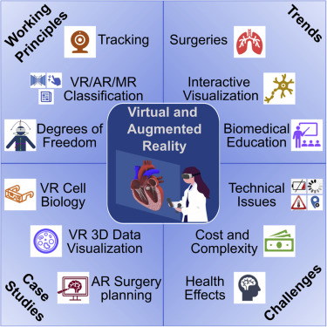
Figure 2: Graphical session of augmented reality applications.

Working Principles of extended reality

XR based on to combine the AR and VR segment technology into a one framework. It classify the process of identification various disease particular elements, and able to work more effectively in advance. Beside this virtual reality is the process to visualize the object in computer generated environment with interactive software and hardware system. Virtual reality obtain the input from the movement of the headset and track the object with voice and movement of hands, the combinations of hand joy stick and the input button support the input the instruction that execute specifically to develop the system.
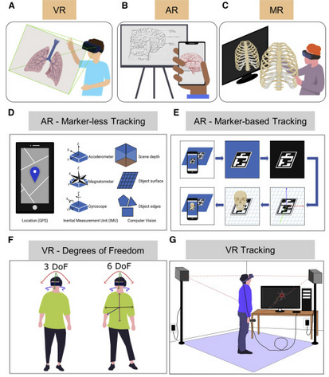
Figure 3: VR AR tracking the object
Currently the trends on Google augmented reality microscope ARM which using the machine learning framework to execute the real time 3D images, the augmented reality system using the deep learning method of neural network to train the model into deep learning methods and produce the meta analysis of breast cancer.
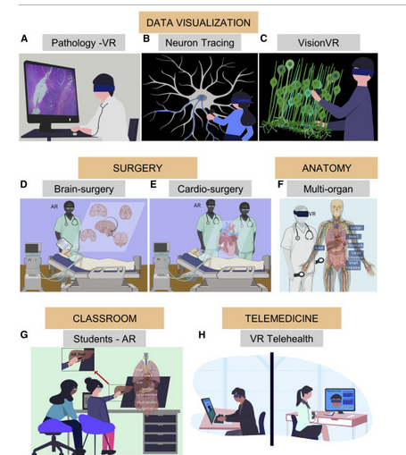
Figure 4: Data Visualization

Visual Design
(Guiseppe, et al., 2021) The visual design of augmented reality system contains the virtual reality feasibility framework, the methods of comprehensive research conducting on systematic review of medical science research to visualize the augmented reality and virtual reality framework in patient anatomy system. The virtual reality devices proved the medical system in more organized way to be treated. Augmented reality involved in orthopedic surgery, it provides the assistance and guidance to the medical surgeon to operate the surgery in organize way. The arrival of artificial intelligence has merged the machine learning and deep learning system technology which used to identify the object, track the object using computer vision sensor imaging technology in the device which effectively produced the high quality output.
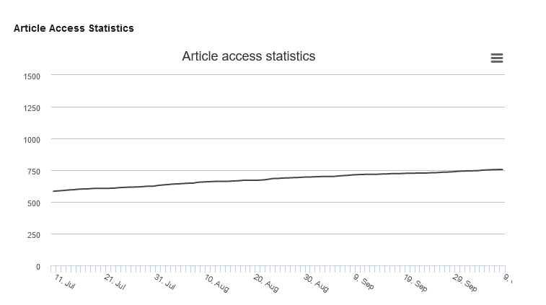
Figure 5: Article access statistics of medical science

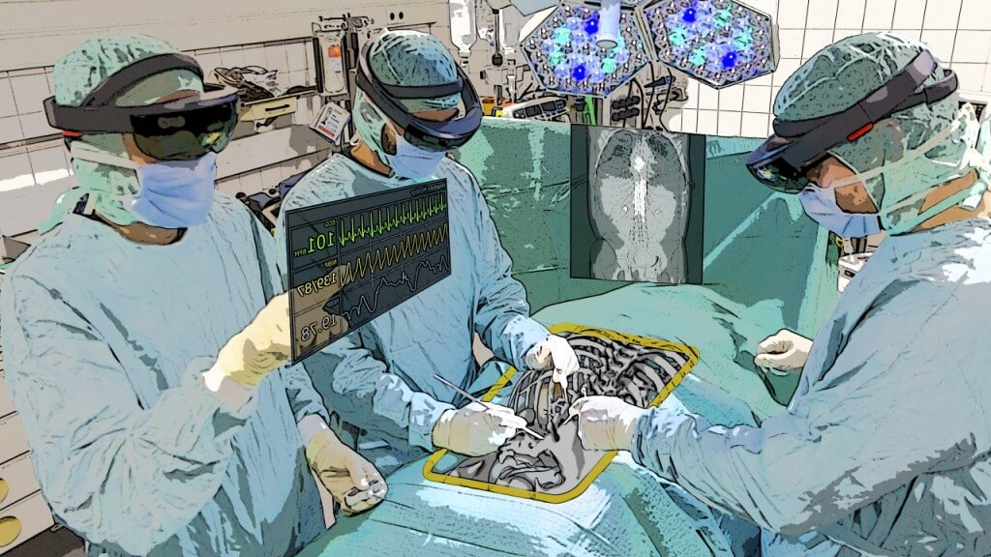
Figure 6: AR in Surgery

Interactive Design of VR AR
(R.Feito, 2020) The user interface of artefact design on wix.com web site. All of the content user interface design should be user friendly. Virtual and augmented reality technology aid the medical surgeon to improve surgical capabilities to aid the technical assistance from the augmented reality based technology. The various medical procedure has been executed on virtual and augmented reality based devices in United States of America and California. The novel method of orthopedic trauma surgery which effectively treat the patient surgery in advance AR technology which tested in USA.

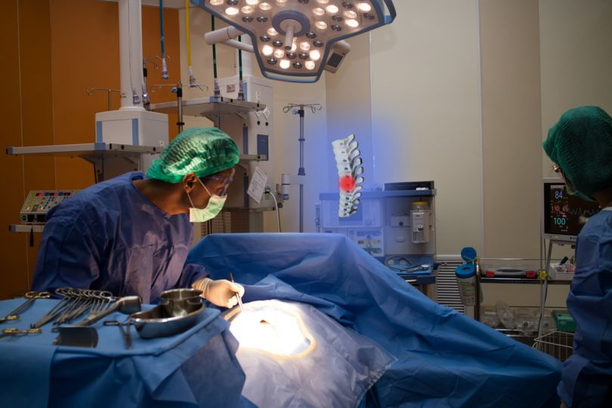
Figure 7: Proprio technology in USA
(Beta, 2021) Virtual reality and augmented reality is not only concerned with the video games and virtual tour segmentation now it’s part of vast medical field which deal the surgery operation simulation processes using the real time scenario. Top 10 virtual and augmented reality companies offers tools to test and verify the process of medical surgical operation. Virtual reality in medical education fields at United States of America providing a great influence towards the patient and the current market of medical equipment treatment. The surgeon mimics the real surgery procedure by deploying the tool of VR and AR based. The question is that the video games could be helpful for the process of operation either true or not, by learning through the 2D and 3D image it would be helpful to developing the augmented reality based medical simulator to identify the process of medical surgery process.
(Proprio, 2021) The technology which is known as Proprio served in Washington United States of America Medicine University. Vast application of Proprio technology which is based on artificial intelligence and virtual reality and augmented reality based technique.
Other technology such as immersive tough, true vision, echo pixel, OSSO VR, Fundamental VR, Senti AR, augmented intelligence, proximine, surgical theater.
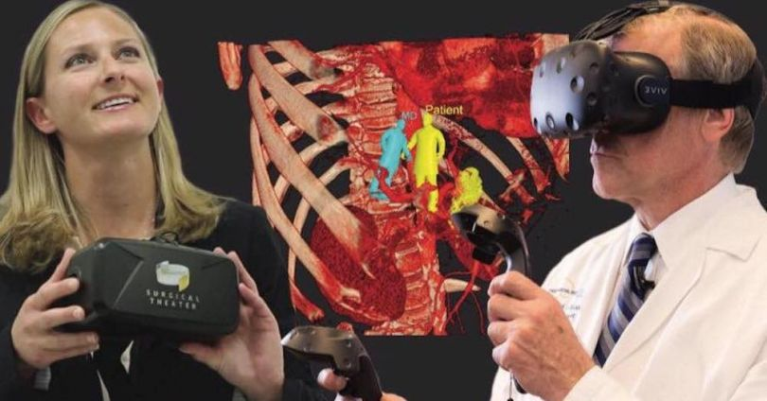
Figure 8: Surgical Theater


Figure 9; augmented intelligence

VIDEO Presentation

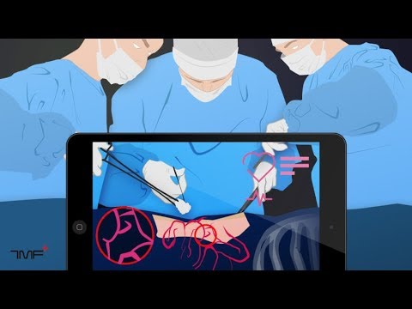

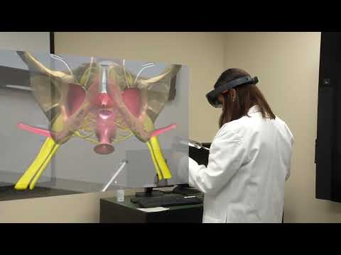

References
Beta, B. i., 2021. 10 companies using VR and AR for surgical operation. [Online]
Available at: https://www.builtin.com/healthcare-technology/augmented-virtual-reality-surgery
[Accessed 8 October 2021].
Giselle Coelho MD, P. N. N. R., 2020. Augmented reality and physical hybrid model simulation for preoperative planning of metopic craniosynostosis surgery. JNS Journal of Neurosurgery, Volume 1, p. 1.
Guiseppe, U., de, S. & De, V., 2021. Augmented Reality, Virtual Reality and Artificial Intelligence in Orthopedic Surgery: A Systematic Review. MDPI applied sciences, 11(7), p. 1.
Proprio, 2021. Proprio. [Online]
Available at: http://www.propriovision.com/surgery
[Accessed 8 October 2021].
R.Feito, J.-C.-R.-P., 2020. The role of virtual and augmented reality in orthopedic trauma surgery: From diagnosis to rehabilitation. Computer Methods and Programs in Biomedicine, Volume 191, p. 1.
Venkatesan, M., Mohan, H. & R.Ryan, J., 2021. Virtual and augmented reality for biomedical applications. Cell report medicine JOURNAL OF SCIENCE DIRECT, 2(7), p. 1.

